Sacramento-Sierra Arson Task Force
Presents
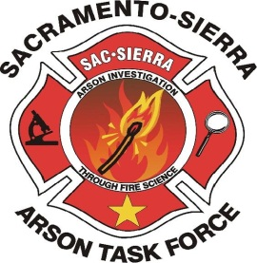
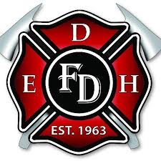

Interview and interrogation
What: The Sacramento-Sierra Arson Task Force will be hosting a 3-day interview training.
Who: This training is for any public safety personnel looking to sharpen their interview skills.
When: April 26-28, 2017
8:00 – 5:00

Where: El Dorado Hills Fire Station
1050 Wilson Boulevard
El Dorado Hills, CA, 95762

Instructor: Sgt Don Davis

Cost: $175 for non-members
Free for SSATF members
Registration: www.ssatf.org – Register on the “Training” page
***CLASS SIZE IS LIMITED TO 30 STUDENTS***
Questions: Brian Parker, Training Coordinator
brian.parker@atf.gov
925-364-8512

